DBMS Technical Task
Dhanalakshmi K
E25AI110
BSc. Computer Science
With
Artificial Intelligence

WEEK 9: SALES AND CUSTOMER ANALYTICS SYSTEM
The e-commerce company wants to analyze its sales data to understand customer purchasing behavior, product performance, and revenue trends. The management team needs reports to identify top customers, best-selling products, and profitable categories.
- Apply SQL Aggregate Functions
Aggregate functions perform calculations on multiple records and return a single summarized value.
Functions Covered :
- COUNT() - Counts number of records
- SUM() - Calculates total value
- AVG() - Finds average value
- MIN() - Finds minimum value
- MAX() - Finds maximum value

- Generate Total Sales Reports
Write SQL queries to calculate:
- Total number of orders placed.
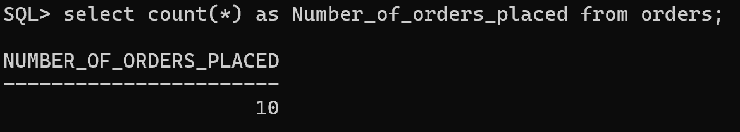
- Total revenue generated from sales.
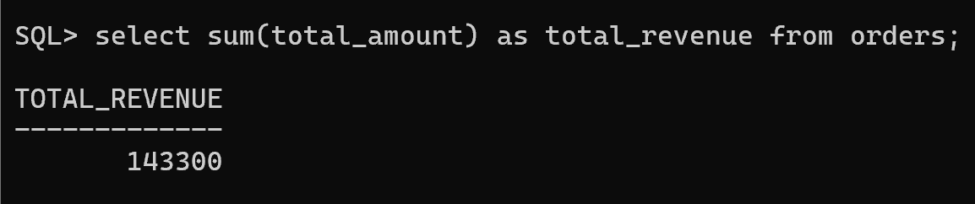
- Average order value.
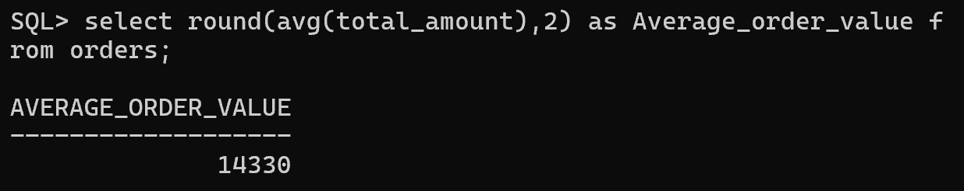
- Highest and lowest order amount.
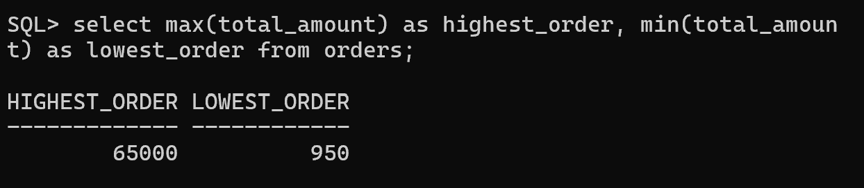
- Total sales for a specific period.
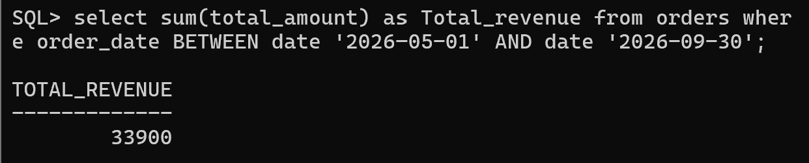

- Customer Purchase Analysis
- Total number of orders placed by each customer.
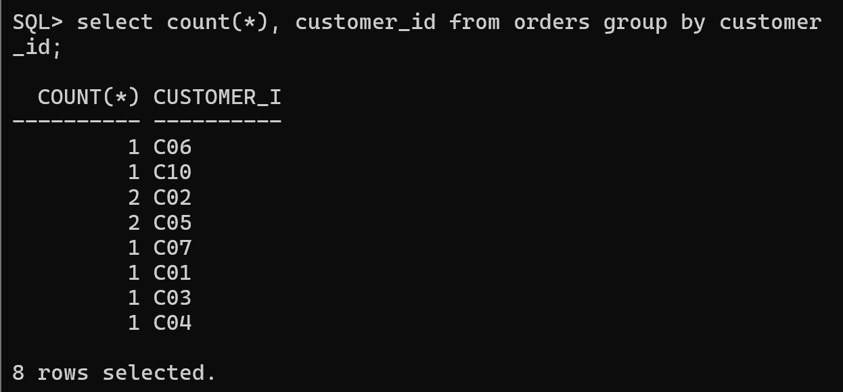
- Total amount spent by each customer.
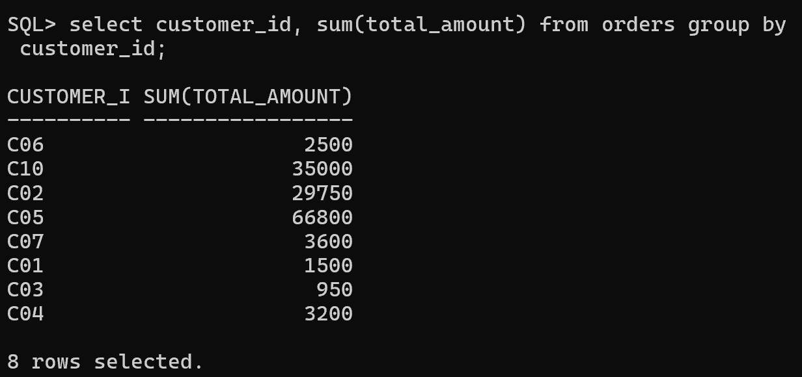
- Average spending per customer.
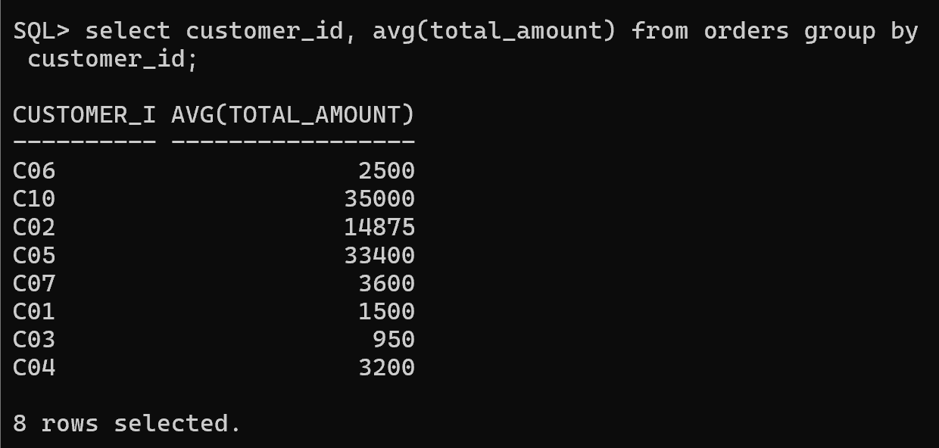
- Customers with maximum purchase amount.
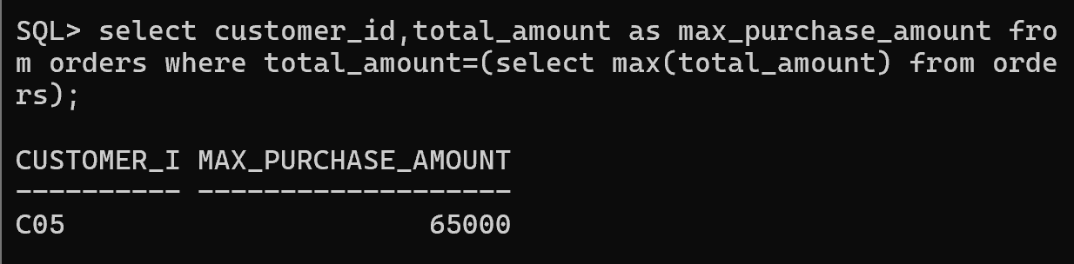
- Customers with fewer purchases.
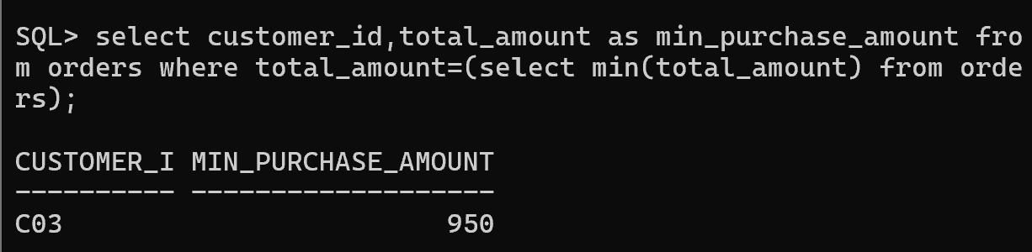

4.Find Top Customers Based on Purchase Amount:
- Top 5 customers based on total spending
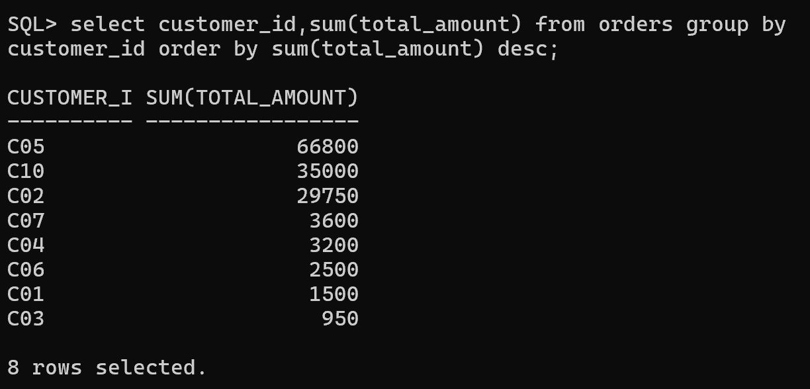
- Customers with maximum number of orders
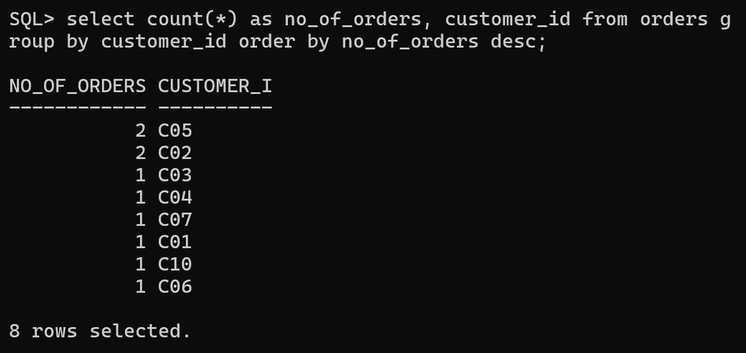
- Frequent customers
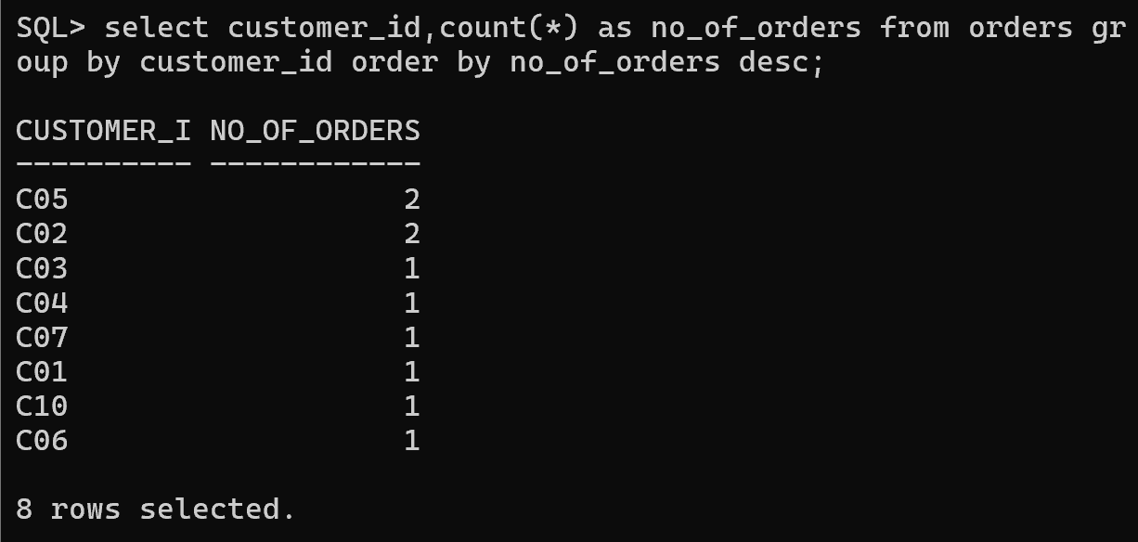
- High-value customers
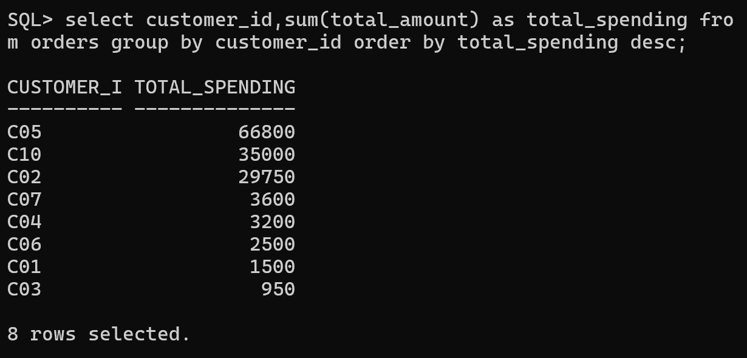

5. Identify Best-Selling Products:
- Products with maximum sales quantity
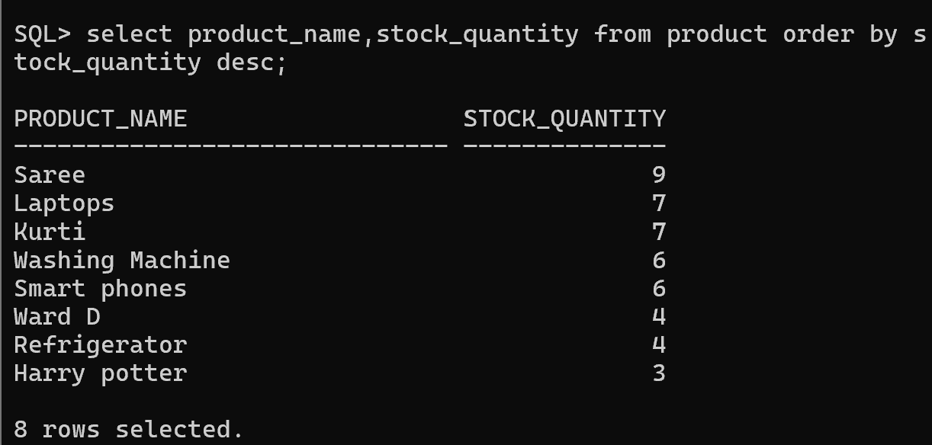
- Products generating highest revenue
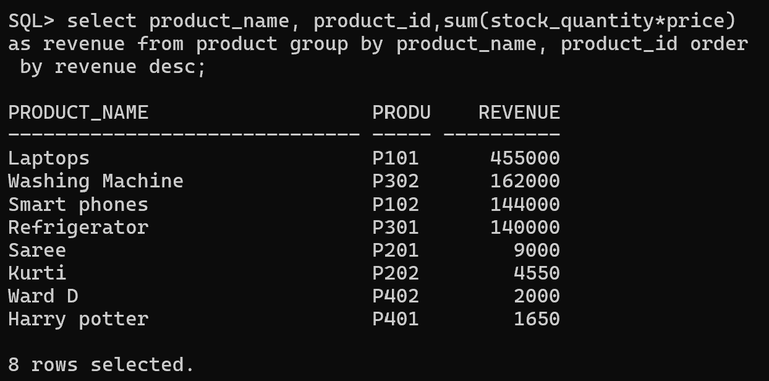
- Least-selling products
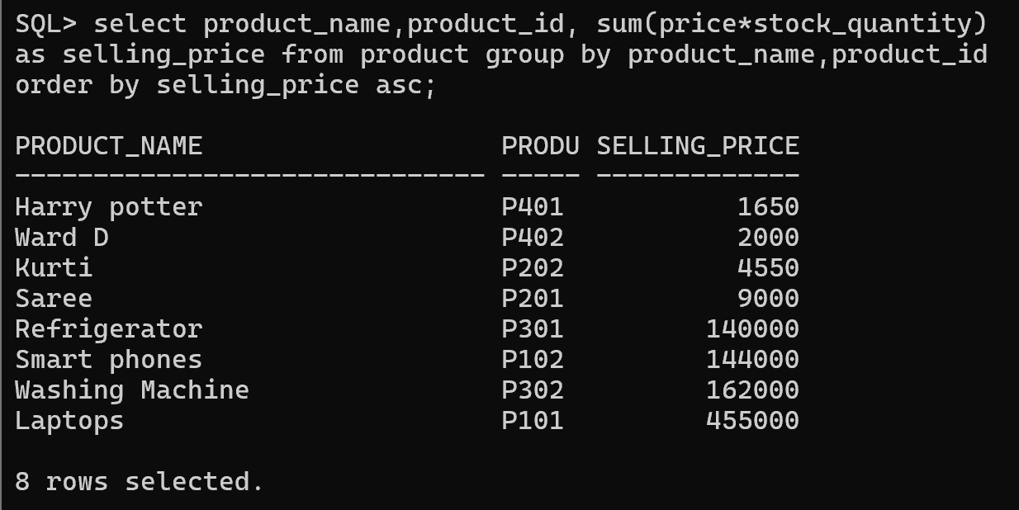
- Products requiring promotion
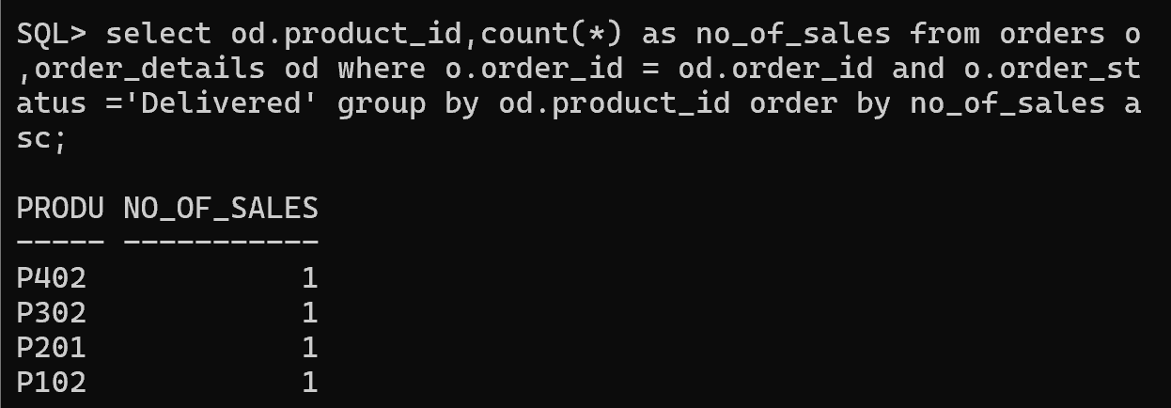

6.Perform Category-wise Sales Analysis:
- Total sales generated by each category.
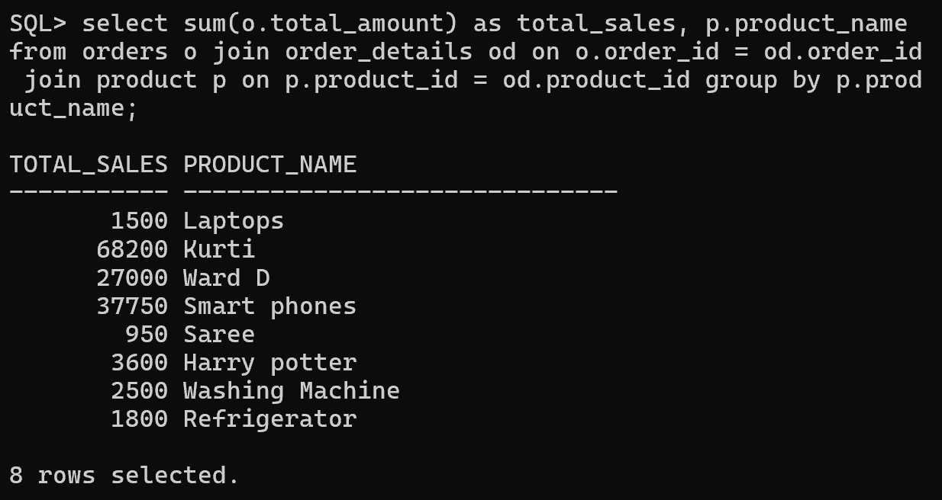
- Number of Products sold in each category.
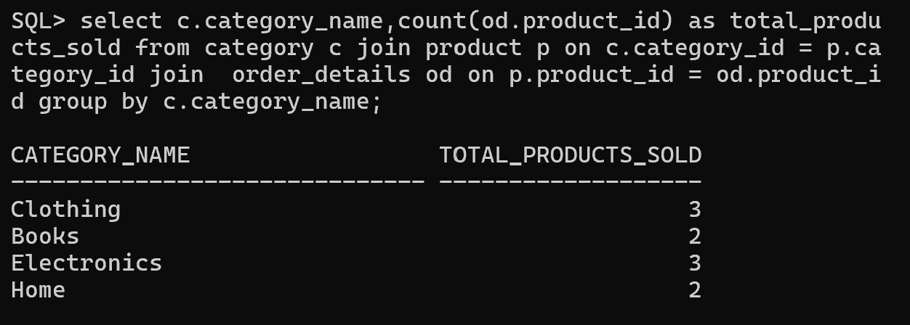
- Highest revenue-generating category.
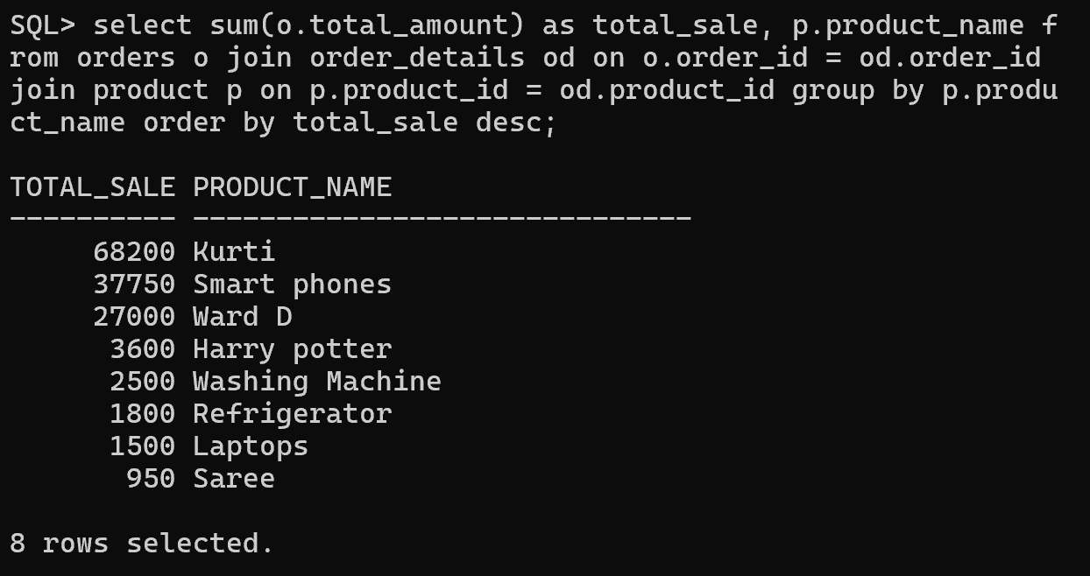
- Average sales per category

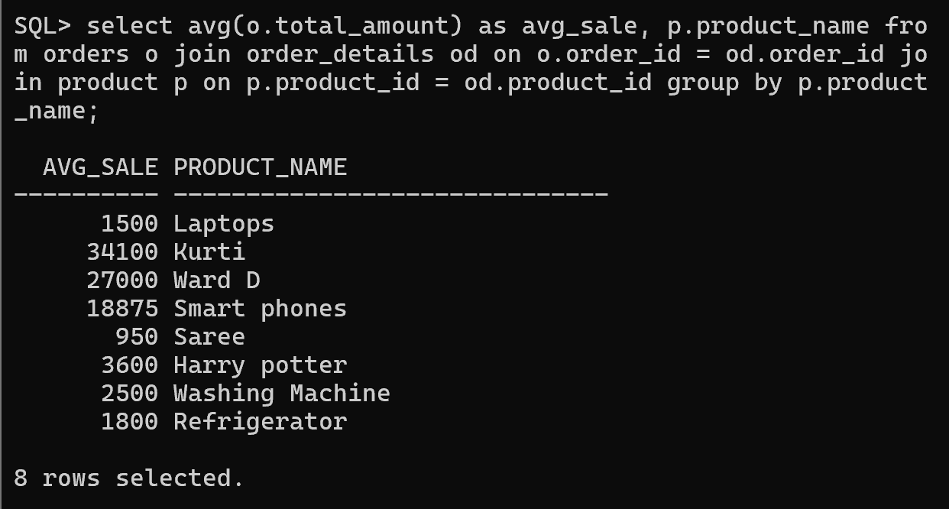

7.Generate Business Analytics Reports:
Report 1: Sales Performance Report:
- Total sales
- Number of orders
- Average order value
- Highest order value
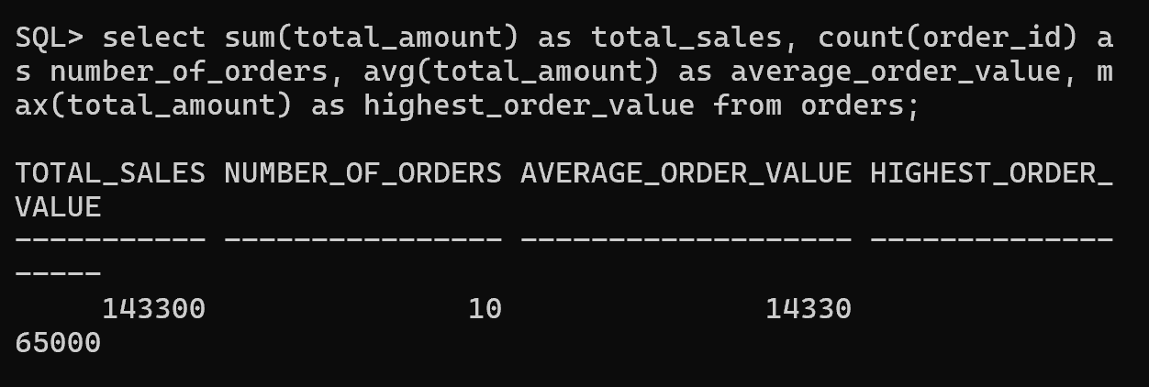
Report 2: Customer Analytics Report:
- Customer name
- Number of orders
- Total spending
- Purchase frequency
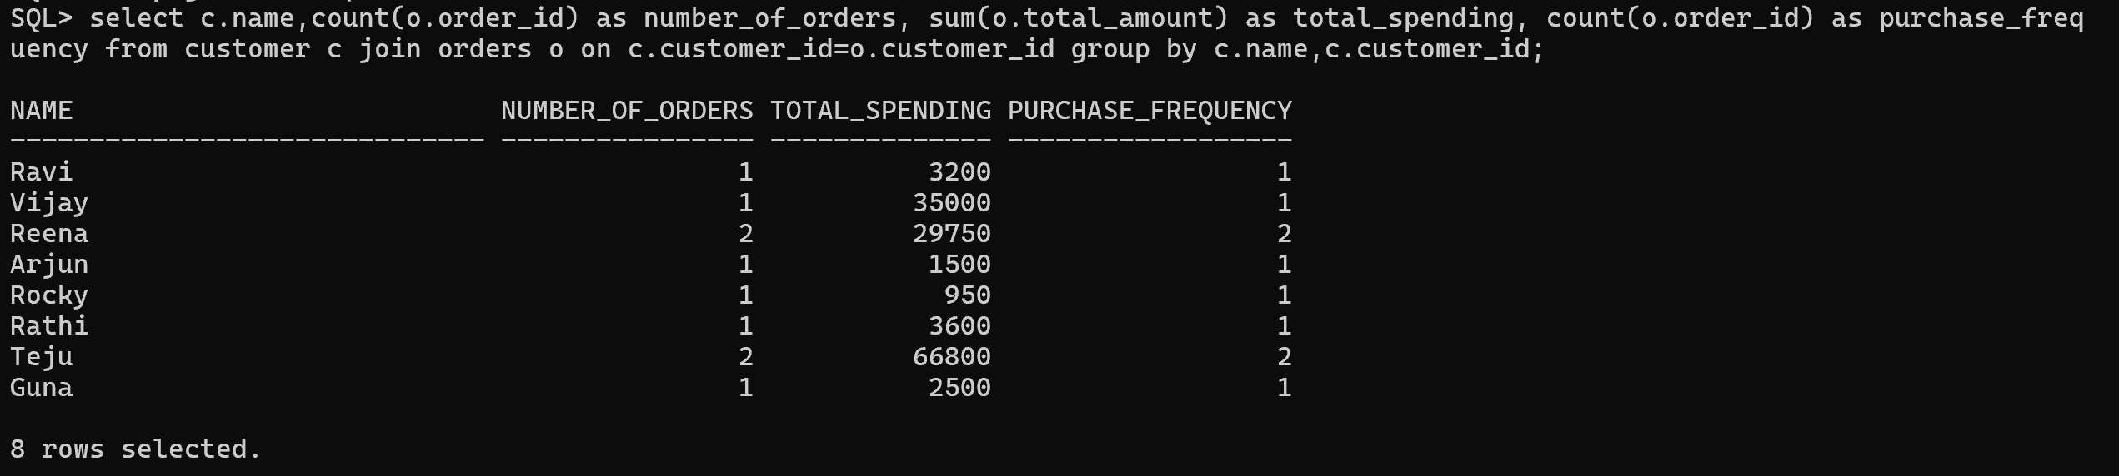
Report 3: Product Performance Report:
- Product name
- Quantity sold
- Revenue generated
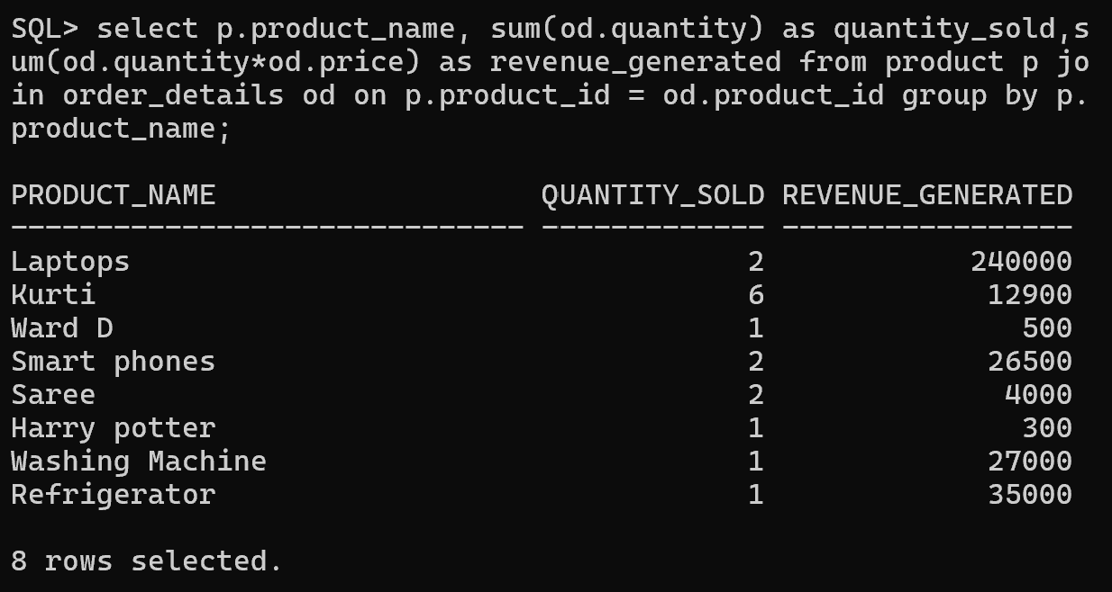
Report 4: Category Analytics Report:
- Category name
- Total products sold
- Total revenue


